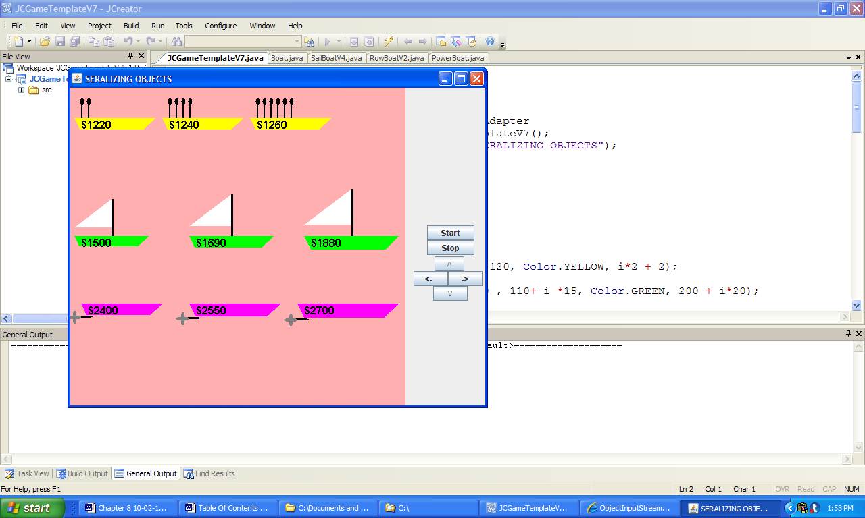 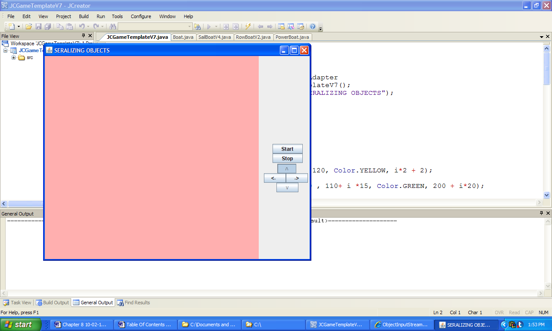

a) b)

**Figure 8.45 Outputs produced by the application SerializingObjects.**